# Chapter 2

## 2.1 Introduction

Requirement analysis is the way to understand the requirements of the users of the system. It explores the expectations of the user about the proposed system. Requirements are actually the descriptions on how the system should work and interact with the user of the system. The efficiency of the final product depends on the accuracy of the requirement analysis.

## 2.2. Requirements Analysis: Facts Analysis

This section requires a fact finding plan to be designed in order for the researcher to be able to proceed with a clear vision from the results of this section. In order to do so the interviewing of key personnel’s who are directly involved with the current manual system and designing of a questionnaire were done in order to meet the requirements. For the researcher to acquire more information for the current manual Tackshop Management System of Chipadze High School, she conducted an observation method and also a document review. The system has put into consideration an error recovery strategy that will ensure maximum data integrity and this is very helpful for the future data requirements and other processes needed by the new automated Tackshop Management System for Chipadze High School.

**2.3 Data Requirements**

The data inputted will be accepted through a products list form which will be stored in the MySQL database for all the processing’s and future data retrievals. As or the output part, it will be displayed to all the users through screen displays of interfaces from the monitors being used.

**Login Form**

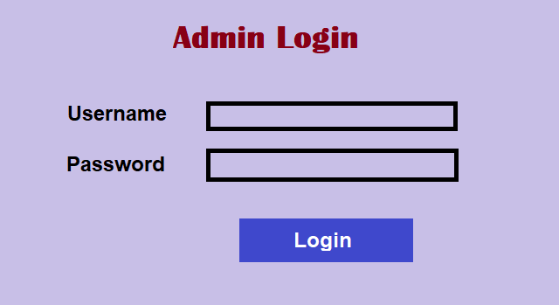

Figure 1 Login Form

This form allows admin and other users to login into the system. First they should enter the credentials provided by Admin. Then the system will check and verify credentials with database. If the credentials are correct it will redirect user to home page else, it will throw an error to the user showing message that the credentials provided are incorrect.

**Product Entry**

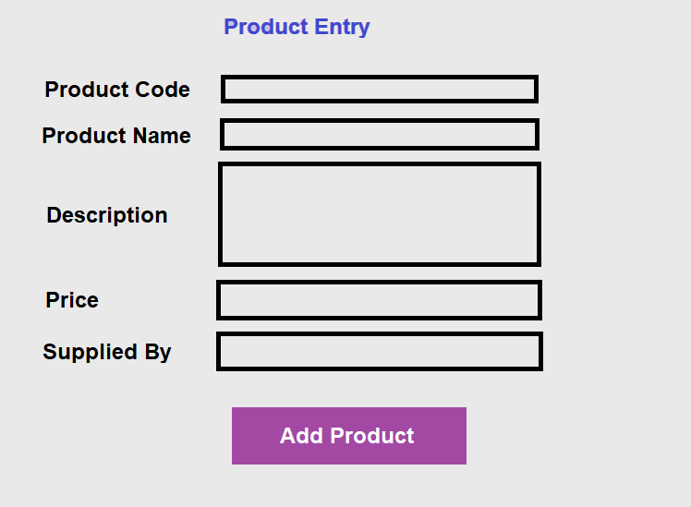

**Product entry form is used to enter product details into the database**

**OUTPUT DESIGN**

**Login**

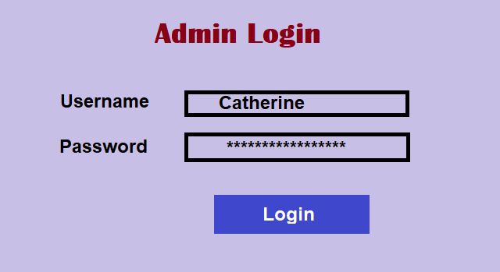

This form shows the credentials entered into the text fields by the users

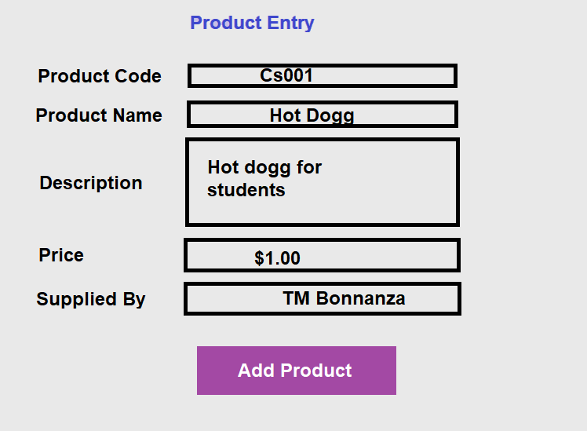

**2.4 Processing Requirements**

***Functional requirements***

It describes the functionality or system services in completing a certain task at hand. In other words, from the word “functional”, it is how the system respond to the set of inputs, the behavior and output. These are unambiguous statements should provide how the system react to a particular input and how the system should behave in particular situations. They include the following:

* The user shall be able to login using registered credentials and the system will display the interface as per user.
* The user shall be able to view products added and total number of products
* The User shall be able to do **CRUD** (**C**reate, **R**ead, **U**pdate, **D**elete).

***Non-functional requirements***

These define the system properties and constraints. They specify criteria that can be used to judge the operation of system, rather than specific behaviors of the system. The non-functional requirements then include:

* The system will be 99% available during scheduled uptime
* The system shall be accurate in the generation of profit.

**2.5 Software Requirements**

The following software will be used in the development of the Tackshop Management System:

* Visual basic.NET programming language
* Windows 10 64bit
* MySQL database
* Microsoft word 2013

**2.6 Hardware Requirements**

It’s highly advised that the most convenient computers to be used should be minicomputers from authorized dealers most advisedly HP*.* This will ensure maximum compatibility, user friendliness, and reliability. HP LaserJet printer is also a hardware requirement.

# Chapter 3: Design

3.1 Introduction